Lab 1: Introduction to EEG

Group Members

Name | UNI
Zhewen Guo (Cap) | zg2567
Thomas Duan | hd2593
Surya Shanmugam | ss7318

Goals
- Understand the 10 - 20 electrode system for EEG;
- Practice EEG cap fitting, gel application, and hardware setup;
- Learn to configure Simulink for EEG signal acquisition and analysis.

Experiment 1: Capping the subject
i. Zhewen (Gustav) was volunteered as the subject for the EEG recordings and was sat in a comfortable chair with arm and back rests before setting the cap. The reference electrode to the earlobe was connected using the clip and the cables for the biosignal amplifier were routed properly to ensure comfort and less interference from noise.
ii. The cap was first adjusted along the sagittal plane using measurements taken from the midsagittal plane using a tape measure. The tape measure was first placed at the Inion reference point, the bony lump at the skull's base along the head's midline. From there it was tightly wrapped alongside the cap to the Nasion, or the bony section of the face along the nose and between the eyes. The distance between the Nasion and the Inion (DNI) was measured to be 40 cm, with 50% of the DNI resulting in 20cm. The cap was then adjusted such that the Cz electrode fell exactly at the 50% DNI measurement along the midsagittal plane.
iii. Next, the cap was adjusted along the axial plane. The tragus of the earlobe was first identified and the subject placed a finger on the tissue while they opened and closed their mouth, when they were able to identify the resulting cavity indentation approximately 1cm from the tragus. The tape measure was wrapped tightly around the top of the head, and the distance between each of these indentations near the tragus was found to be 39 cm, with the 50% measurement of the ear-to-ear distance found to be 19.5 cm. The cap was then adjusted along the axial plane so that the Cz electrode would be positioned exactly at the 50% distance mark, while maintaining the alignment from part i.

Experiment 2: Building up the biosignal recording system and testing the configuration using Simulink
I. Test the biosignal acquisition system with a sine wave
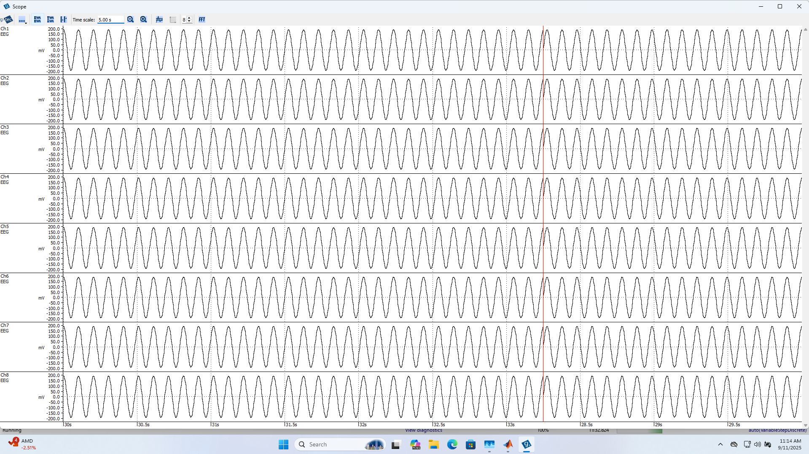
Figure 1. Simulated sine wave
This snapshot of the scope was taken after using a simulated test signal of a sine wave with an amplitude of 200 mV and a frequency of 10Hz, alongside a Notch filter at 60Hz and a bandpass at 0.5-60Hz applied to channels 1, 6, 11, 16, 13, 12, 15, and 14.

II. Use the Simulink module to record EEG data
During the gel-free experiment, the conductive gel was injected into the electrodes of Channel 1, 2, and 3, and we informed the TA of this situation during the experiment. We will also label this information on the images in subsequent steps.

Common Features
- Though slight differences between each channel, the signals appear largely similar.
- Furthermore, by comparing the experiments with and without gel, we can observe that after applying the gel, more accurate EEG signals can be captured. This phenomenon is attributed to the gel building connections between the electrodes and the scalp, making the EEG signal easier to capture.
- By comparing the experiments with and without filters, the range of signal values increases substantially (e.g., in Step iv, removing the filter causes the range to increase from 400 μV to 1 mV, with the noise overwhelming the signal). Also, it is evident that the unfiltered signals contain more noise. This is because the filter eliminates the irrelevant signals (noise) from the EEG ones.

i. Blinking eyes
From the figure, we can see that every time the subject blinks, the EEG signal shows a spike-like disturbance, making the overall signal appear similar to a sine wave. The peak value of the signal is around 200 μV, and the period is approximately 0.25 seconds, which should be strongly correlated with the subject's blinking frequency. It’s also worth mentioning that the first channel captures the most intense signal, which could be due to the node being the closest to the eyes, capturing some skin movements as well.
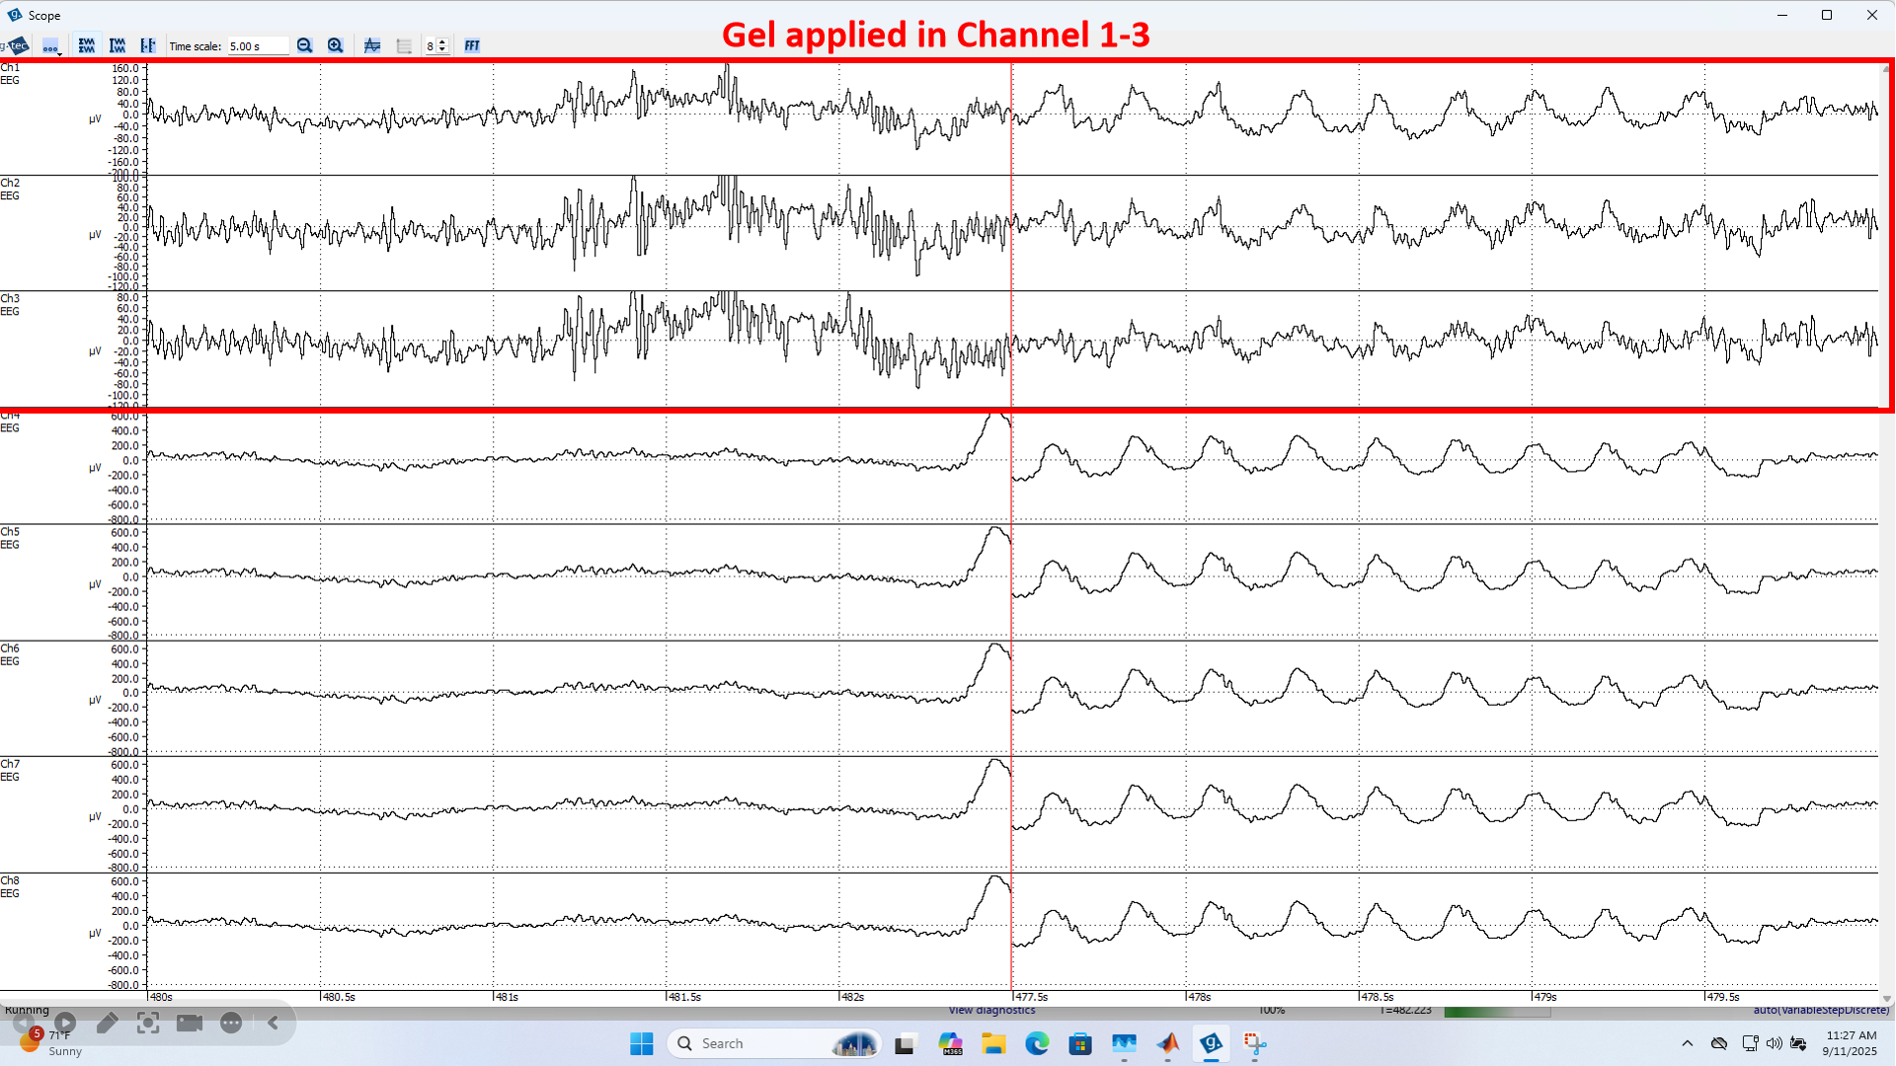
Figure 2. Blinking Eyes (No Gel With Filter)

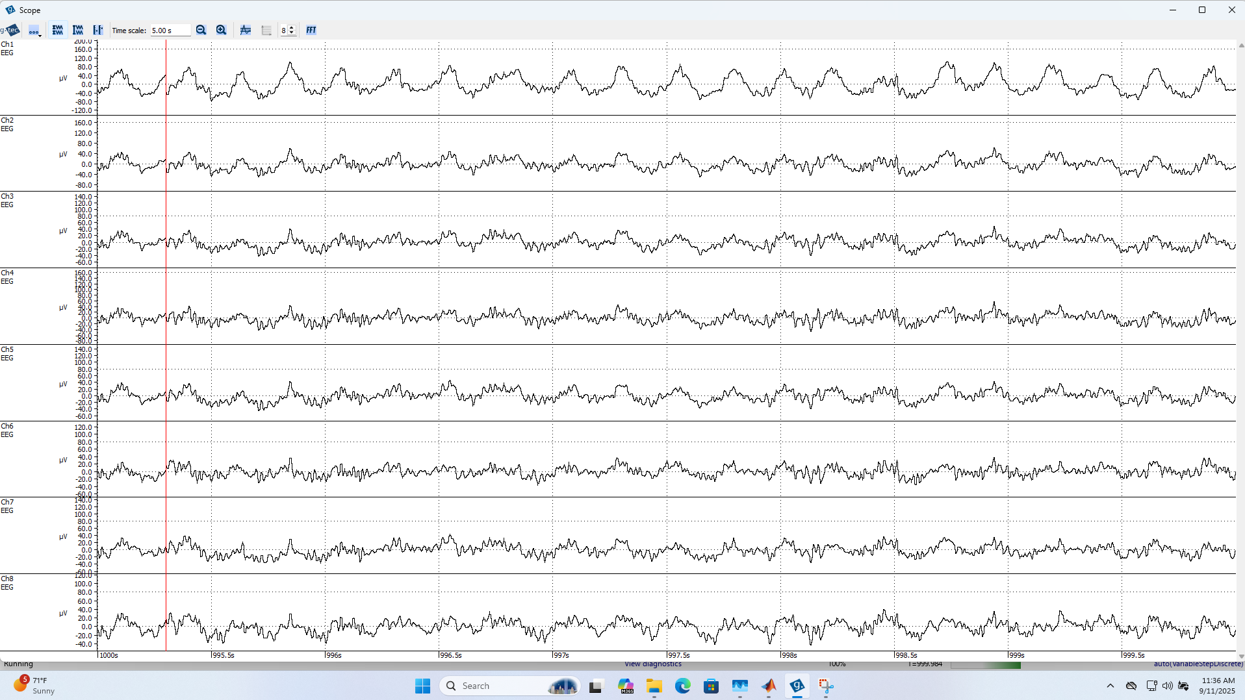
Figure 3. Blinking Eyes (With Gel With Filter)
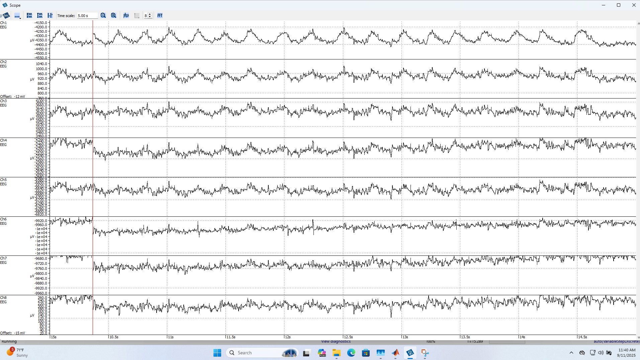
Figure 4. Blinking Eyes (With Gel No Filter)

ii. Rolling eyes
Through this step, we can observe that the EEG signal exhibits properties of low frequency and irregularity. The signal value fluctuates between -300 μV and 200 μV, and it is pretty hard to tell the period of the signal, which may be related to the irregular eye movements of the subject. Additionally, compared with Step i, the signal appears to be rougher, which may be associated with ocular movement artifacts.
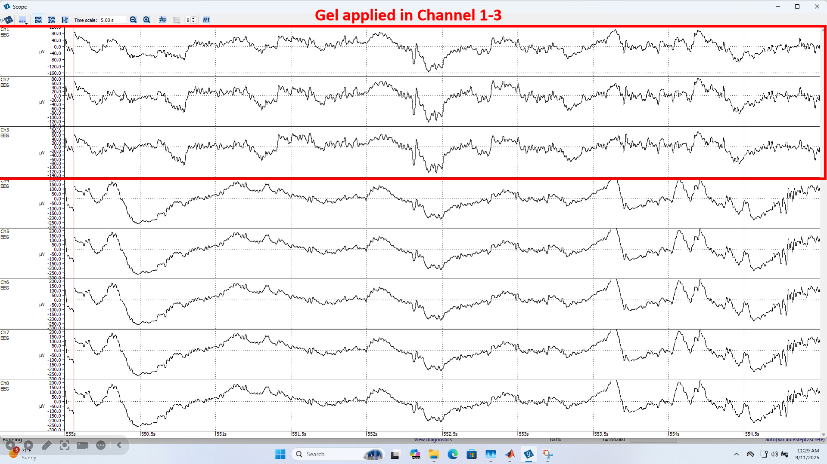
Figure 5. Rolling Eyes (No Gel With Filter)
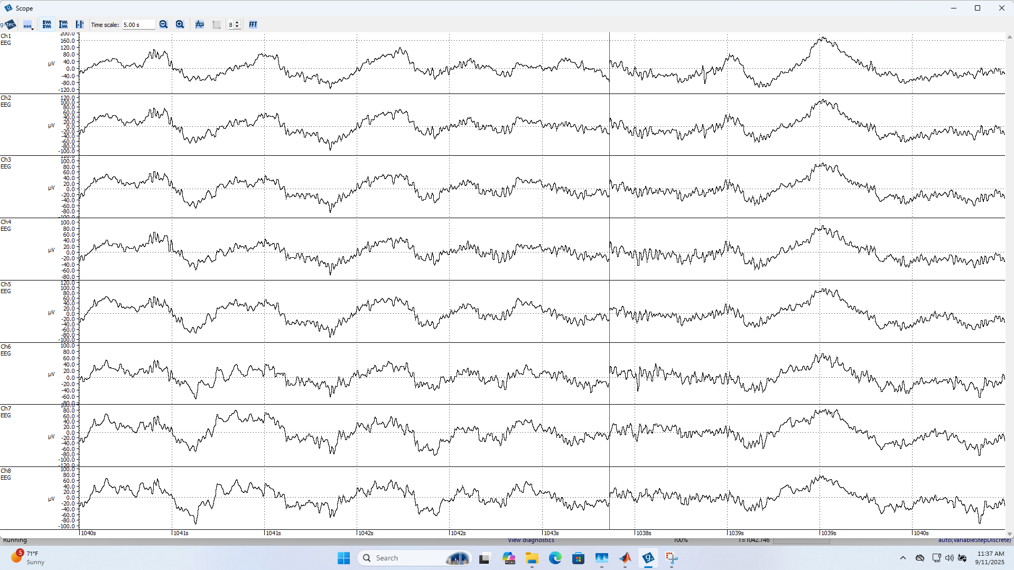
Figure 6. Rolling Eyes (With Gel With Filter)

Figure 7. Rolling Eyes (With Gel No Filter)

iii. Tensing neck muscles
From this step, it is obvious that every time the subject tenses his neck muscles, the EEG signal shows a period of high-frequency disturbances, with signal values ranging from -100 μV to 30 μV. When the subject relaxes, these disturbances disappear.
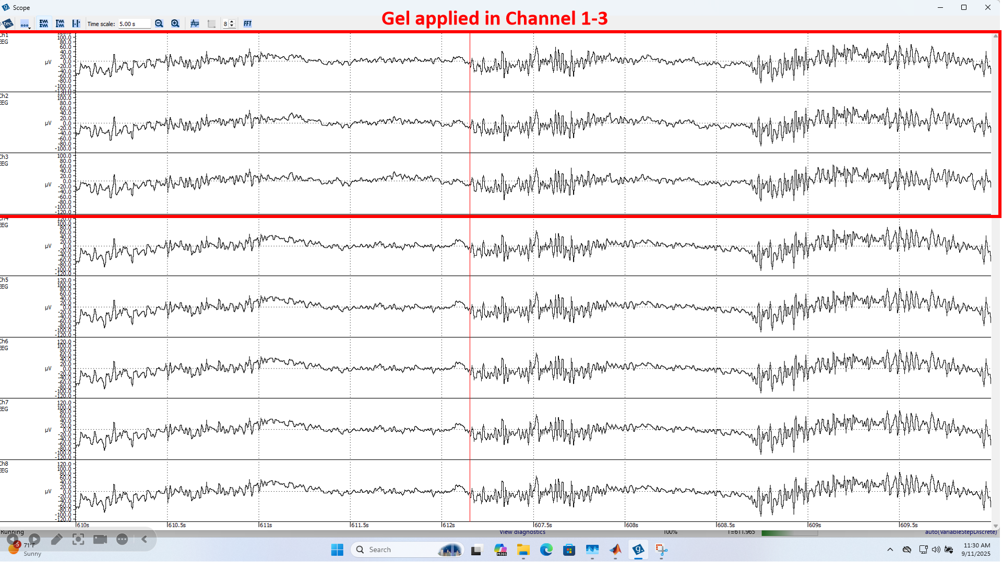
Figure 8. Tensing neck muscles (No Gel With Filter)

Figure 9. Tensing neck muscles (With Gel With Filter)
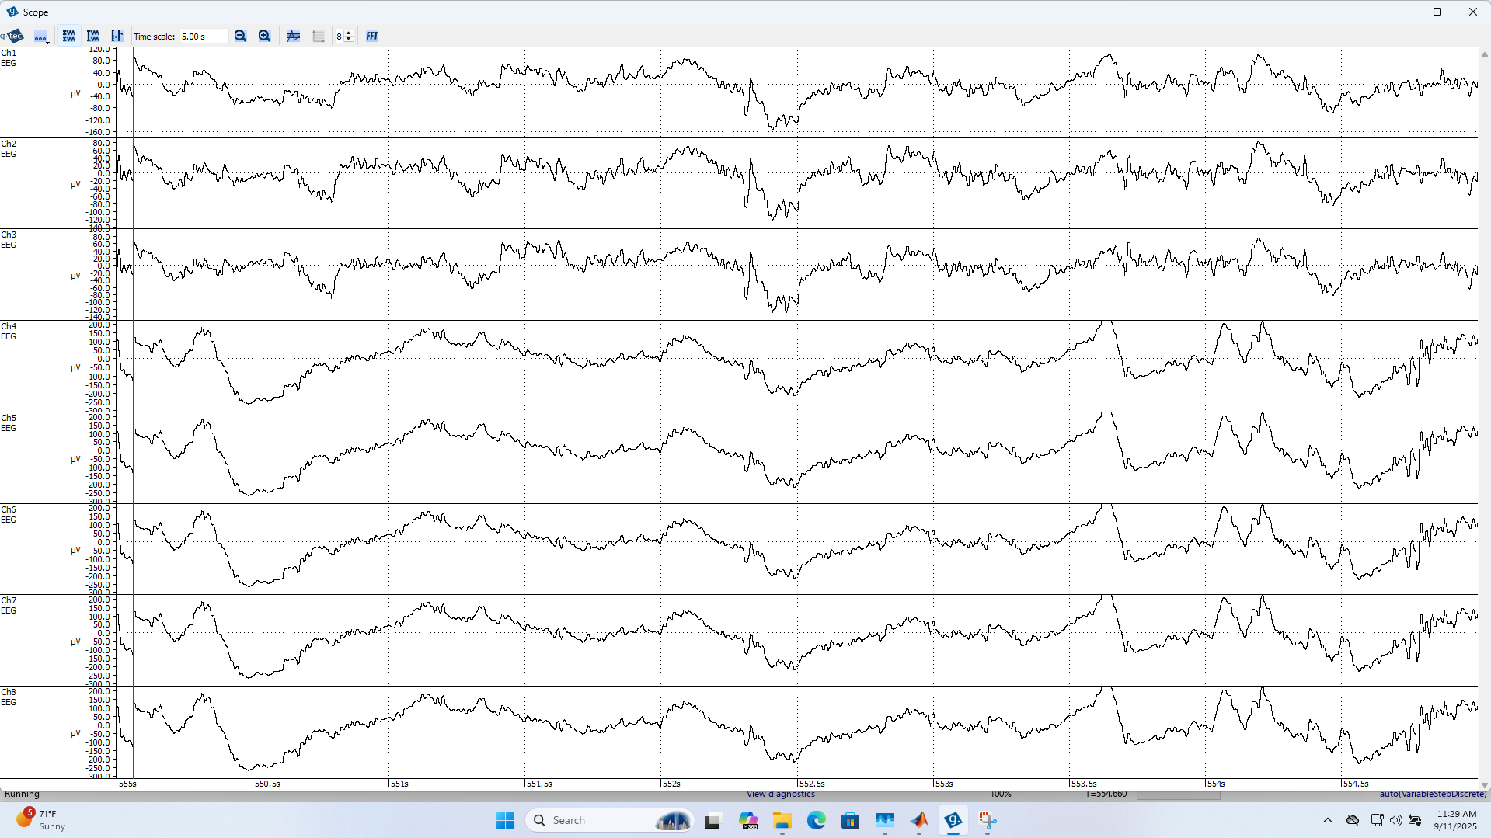
Figure 10. Tensing neck muscles (With Gel No Filter)

iv. Clenching jaw
From the figure below, the signal is quite similar to the one in step iii. Every time the subject clenches his jaw, there is a period of high-frequency disturbances that disappears after the subject relaxes. And the values range from -100 μV to 30 μV.
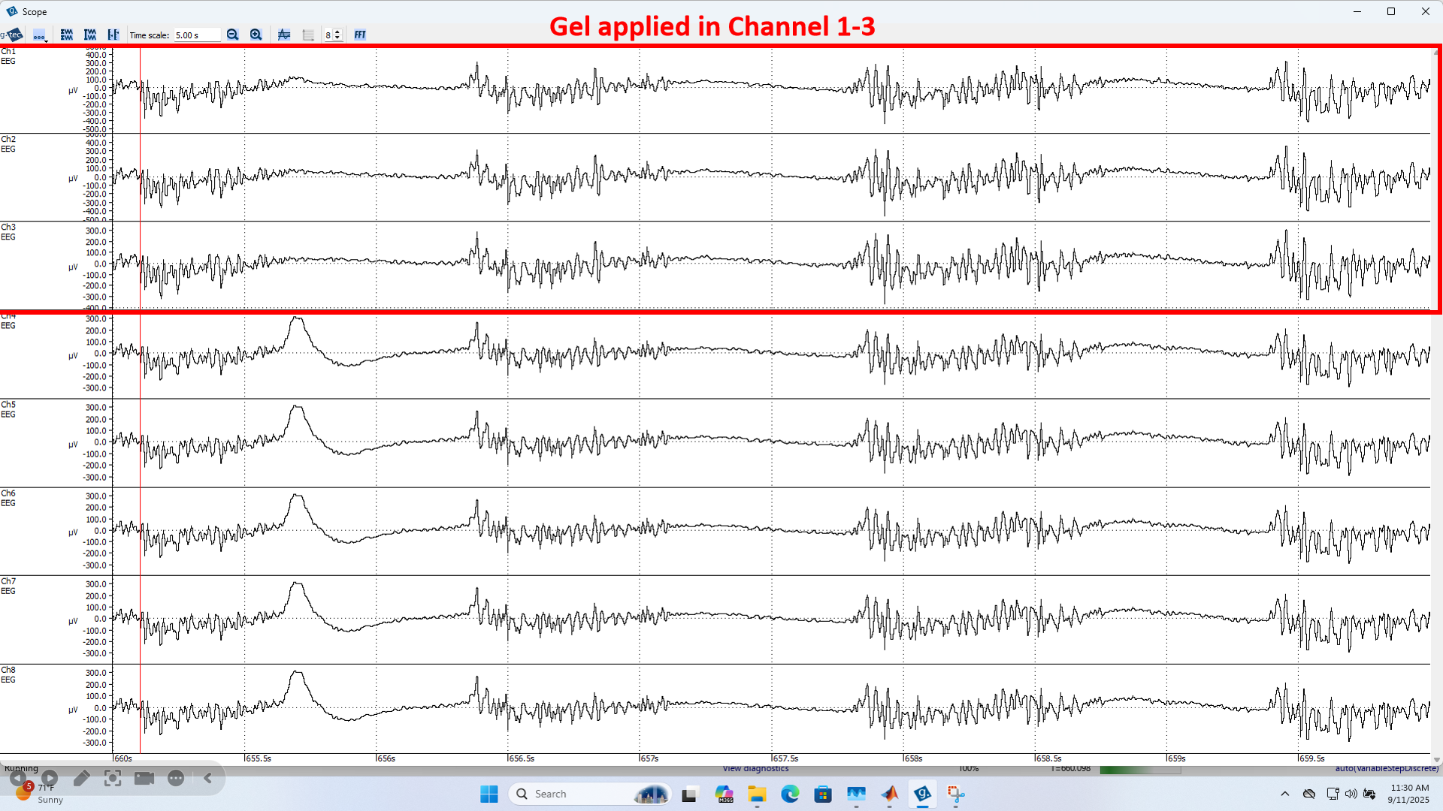
Figure 11. Clenching jaw (No Gel With Filter)
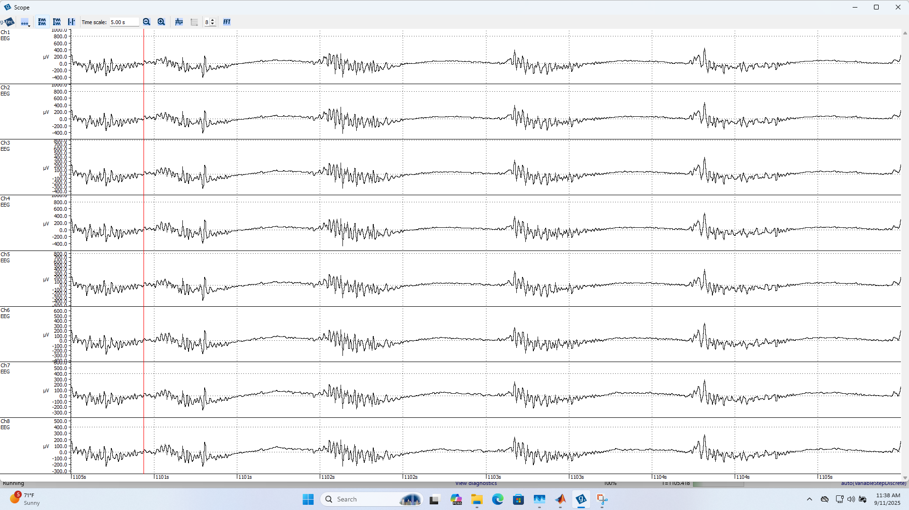
Figure 12. Clenching jaw (With Gel With Filter)

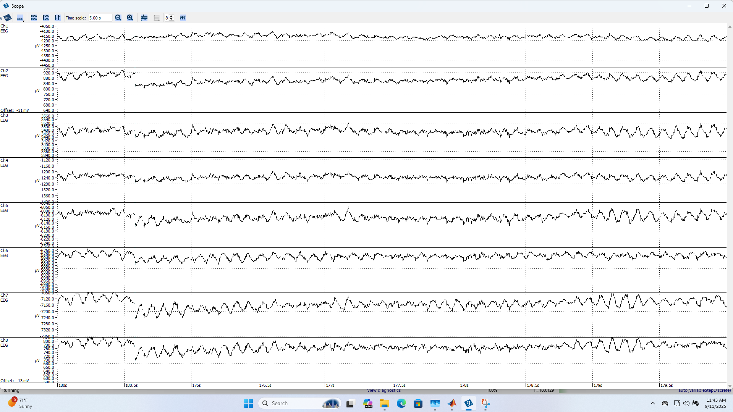
Figure 13. Clenching jaw (With Gel No Filter)

v. Closing eyes
When the subject closes his eyes and relaxes, the amplitude range decreases slightly (from –30 μV to 60 μV). The signal appears irregular, and its period is difficult to determine.
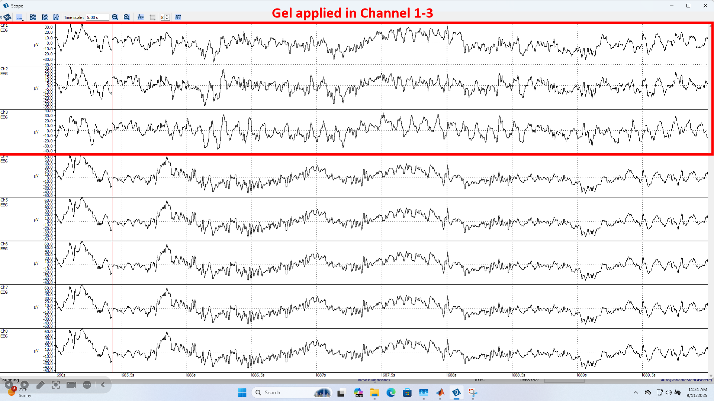
Figure 14. Closing Eyes (No Gel With Filter)

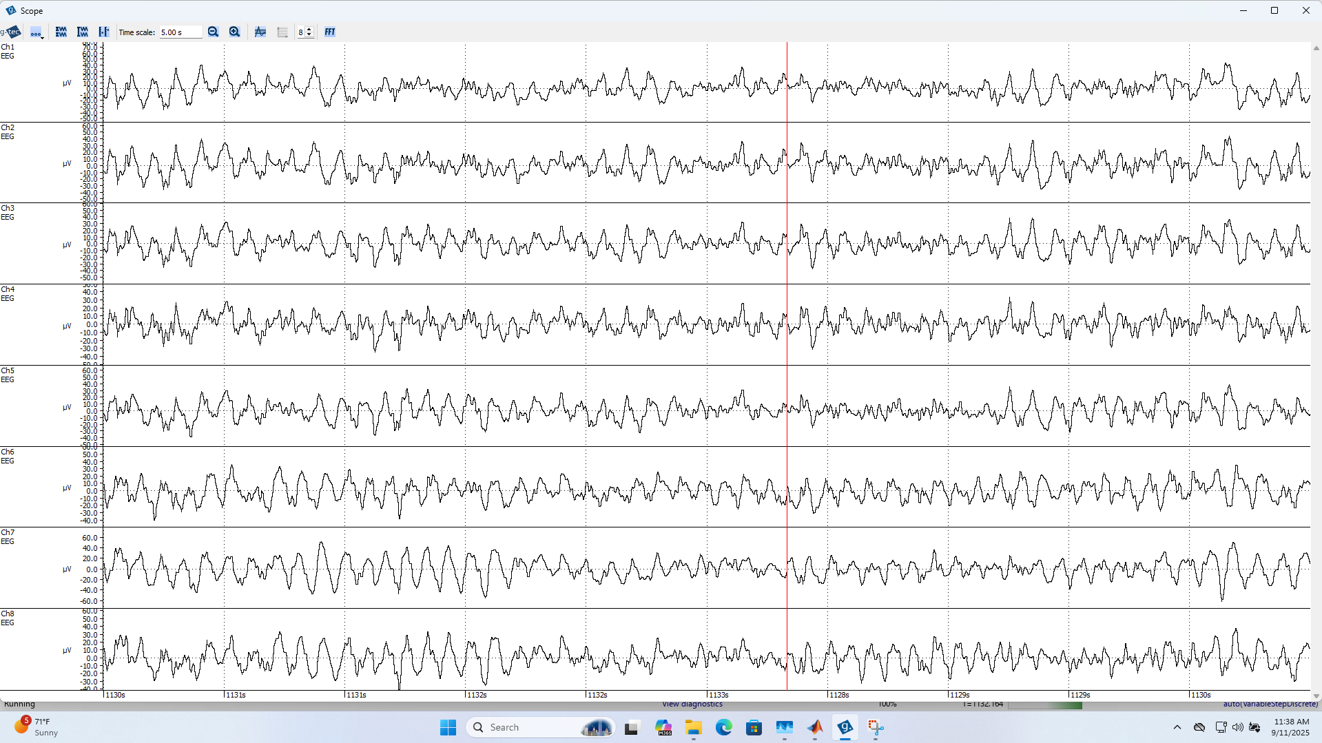
Figure 15. Closing Eyes (With Gel With Filter)
Figure 16. Closing Eyes (With Gel No Filter)

